The National Gazette
Friday, 29 May 2026

Anna Ha
The Missouri Compromise: A Fragile Peace in a Divided Nation
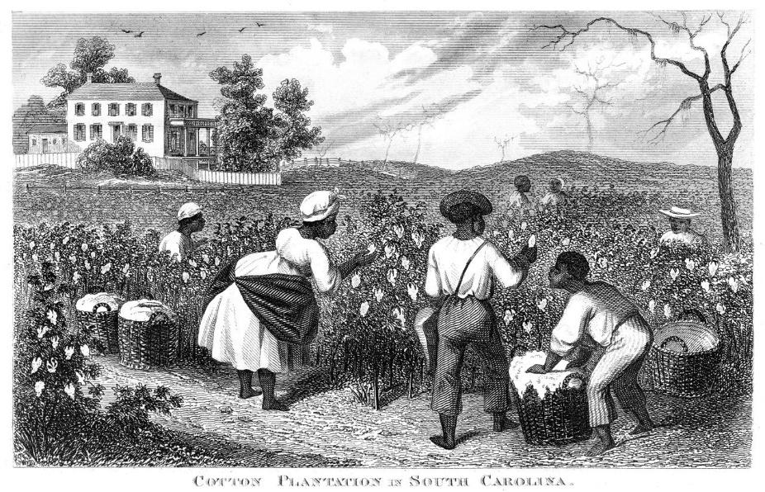
English colonists brought slaves to North America from Africa in the early 1600s. Slaves cleared the land and prepared it for farming. Slaves were forced to leave their homes in Africa. They were placed on crowded slave ships to cross the Atlantic Ocean. Many slaves worked on tobacco, sugar, and cotton plantations. Others worked in the homes of their owners. Their work helped to develop the economy of the United States.
As the country grew, people’s views on slavery started to change. Many people in the North wanted to abolish slavery. In the South, where the economy was based on farming, most state representatives hoped to keep and even expand slavery into the country’s new territories. In the early 19th century, some states were known as free states and others were slave states. Free states did not allow slavery, while slavery was legal in slave states.
In 1818, there were 11 free states and 10 slave states in the U.S. This same year, Missouri, a territory where slavery was legal, applied to become a state. The debate began when Missouri asked to join the Union as a slave state. Many people in the North opposed the expansion of slavery, while many in the South wanted to protect it. Congress had passed a new agreement known as the Missouri Compromise in an effort to settle a growing dispute over slavery in the western territories.
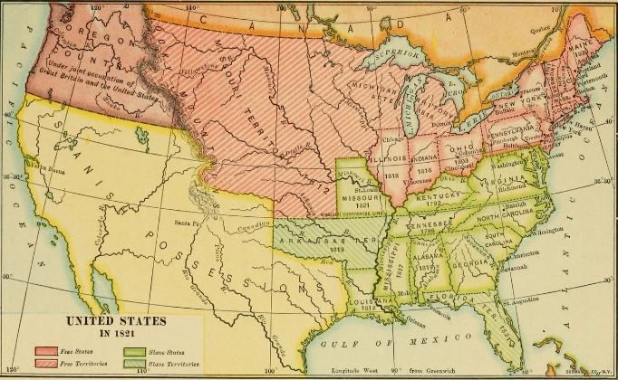
The compromise allowed Missouri to enter the Union as a slave state and Maine to enter as a free state. This kept the number of free and slave states equal. Congress also decided that slavery would not be allowed in most of the Louisiana Territory north of the 36 degrees 30 minutes line, except for Missouri. For almost 30 years, states were admitted in pairs to maintain the balance of powers: one free state and one slave state. When the United States gained more land after the Mexican-American War, the debate about slavery in the new territory started again.
Many citizens hope this agreement will preserve peace between the North and South. However, some leaders believed the compromise only delayed a larger conflict. Although the Missouri Compromise settled the current dispute, the question of slavery in new territories remains unresolved. It created a division in the country between the North and South. Disagreement about a state's right to enact slavery, and the federal government’s right to restrict it, eventually led to the American Civil War.

